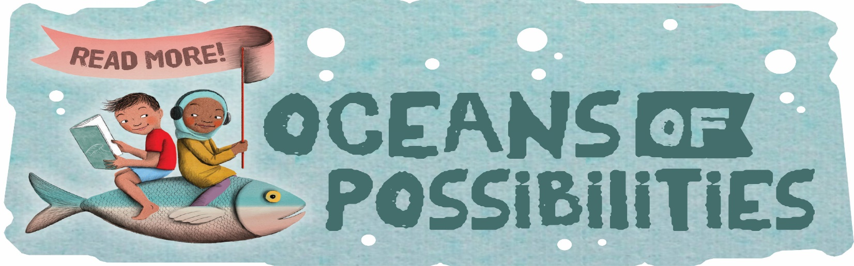Benedek Memorial Library’s
Summer Reading Plus 2022
Juvenile Registration
Name: ____________________________________________________
Address: __________________________________________________
Phone: ___________________________________________________
Age: _____________________ Please circle: Boy Girl
School: _________________________ Grade in September: _________
Circle one: Independent Reader Family Reader
Parent/Guardian: ____________________________________________

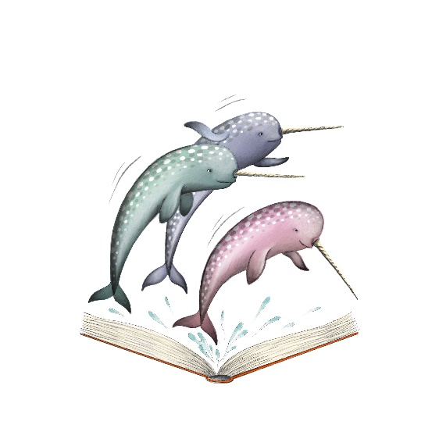

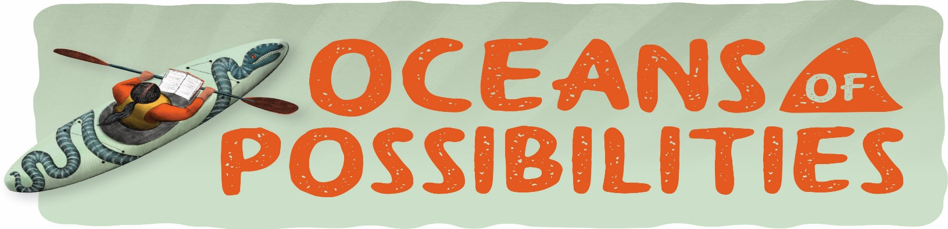
Benedek Memorial Library’s
Summer Reading Plus 2022
Young Adult/Adult Registration

Name: ____________________________________________________
Address: __________________________________________________
Phone: ___________________________________________________
Age: _______________ Please circle: Male Female Them
Young Adults:
School: _________________________ Grade in September: _________
Parent/Guardian _____________________________________________

