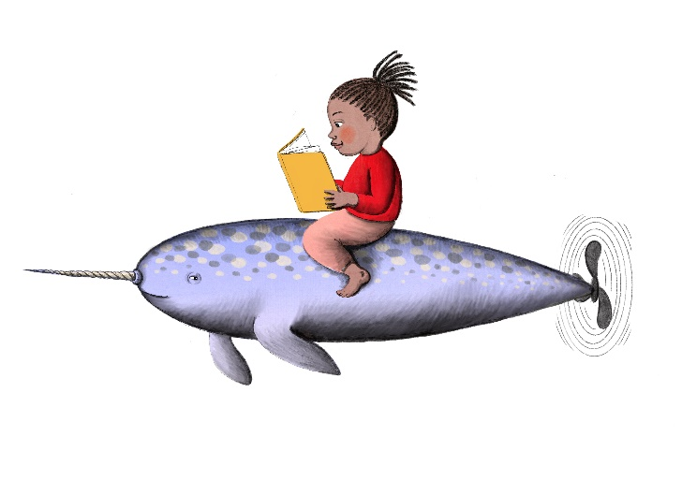
Oceans of Possibilities
Summer Reading Plus 2022
Benedek Memorial Library
Reading Log
Please record your reading times in minutes from July 2 – August 13, 2022

Reader’s Name: ____________________________________________________________________
Parent/Guardian (if under 17 yrs.) ______________________________________________________
Title Pages Date/Minutes
Ex. Harry Potter and the Sorcerer’s Stone_______________ _10-15___________ __7/6- 5 min__
_________________________________________________ _________________ _____________
_________________________________________________ _________________ _____________
_________________________________________________ _________________ _____________
_________________________________________________ _________________ _____________
_________________________________________________ _________________ _____________
_________________________________________________ _________________ _____________
_________________________________________________ _________________ _____________
_________________________________________________ _________________ _____________
_________________________________________________ _________________ _____________
_________________________________________________ _________________ _____________
_________________________________________________ _________________ _____________

 
 
 

