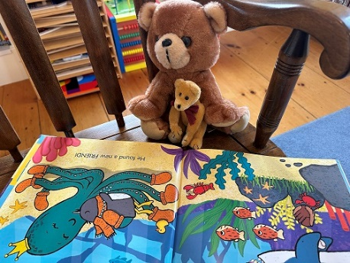
Adopt a Reading Buddy
Reading Log

Your name: ________________________________________ Grade in School: ____

Title of Book Date Minutes read
____________________________________________________________________________________________________________________________________________________________________________________________________________________________________________________________________________________________________________________________________________________________________________________________________________________________________________________________________________________________________________________________________________________________________________________________________________________________________________________________________________________________________________________________________________________________________________________________________________________________________________________________________________________________________________________________________________________________________________________________________________________________________________________________________________________________________________________________________________________________________________________

